Former Standard Operating Procedure for CO₂ Adsorption Experiment

This SOP describes the deprecated step-by-step method for operating the SUTD fixed-bed experimental setup to conduct CO₂ adsorption breakthrough experiments using C3 (PEI@SiO₂) granules as the solid sorbent. The aim is to observe the behaviour of the system under initial and boundary conditions across repeated experimental runs and obtain breakthrough data for subsequent breakthrough parameters estimation and modelling. Fig. 7. shows the labelled valves (1, 2, 3, 4, and 5). Fig. 8. shows the process flow diagram of the CO₂ adsorption experiment in packed-bed column.
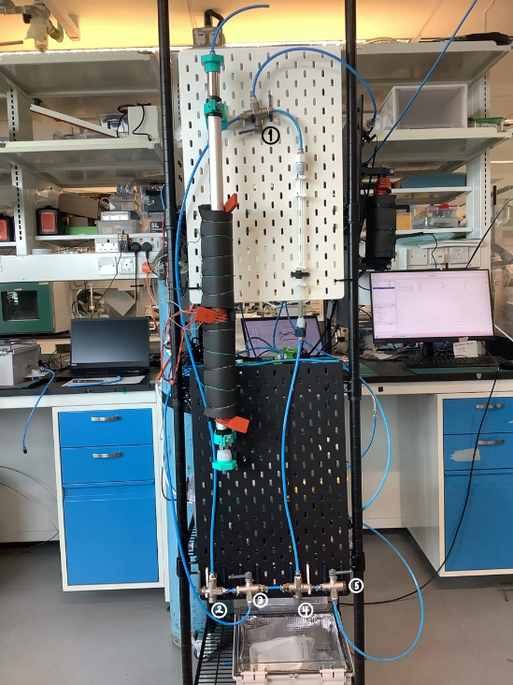
Fig. 7) labelled valves and apparatus for SUTD CO2 Adsorption experiments.
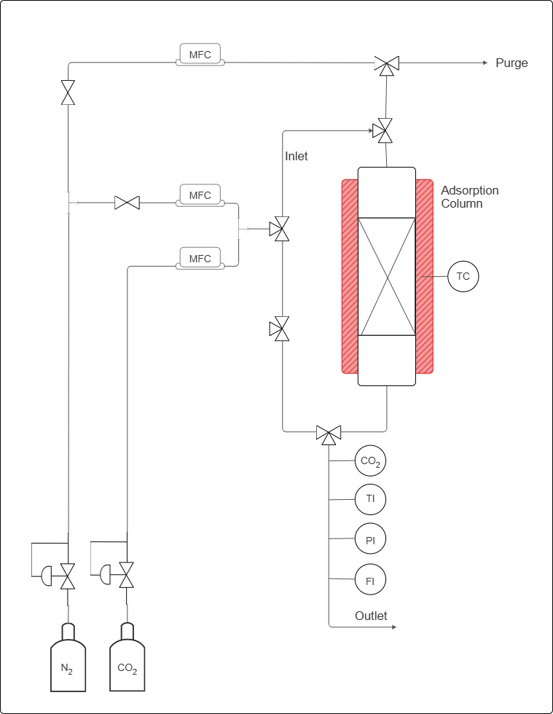
X%
CO2 (v/v)
CO₂ concentration
Gas stream temperature
Gas stream pressure
Gas stream flow rate
PEI@SiO2 granules bed
Heat for regeneration
To purge column before starting adsorption

Fig. 8) labelled process flow diagram of CO₂ adsorption in fixed-bed column.

4.1 Apparatus and Instrumentation
The apparatus comprises a gas-feeding section, an adsorption column, and a gas analysis section at the outlet, as described below.

4.1.1 Gas Feeding Section
Two compressed gas cylinders with pure CO₂ and pure N₂ is fitted with a dedicated pressure regulator and a manual needle valve. Three mass flow controllers (MFCs) regulate the volumetric flow rates throughout the experiment:
- MFC-A (top position): controls the N₂ flow used exclusively for the pre-adsorption column purge and for the regeneration purge sweep.
- MFC-B (middle position): controls the N₂ flow during the adsorption step, contributing to the binary N₂/CO₂ feed mixture.
- MFC-C (lower position): controls the CO₂ flow during the adsorption step; blended with the N₂ stream from MFC-B to produce a feed gas of composition X% CO₂ (v/v), where X is a pre-specified experimental variable.
The mixed gas stream is produced by combining the outputs of MFC-B and MFC-C at a T-junction downstream of both controllers, prior to entry into the column inlet.

4.1.2 Adsorption Column
The fixed-bed column is oriented vertically with gas entering at the bottom inlet and exiting at the top outlet. The column, with an inside diameter of 8.2mm and length of 32cm is packed with PEI@SiO₂ granules.

4.1.3 Gas Analysis and Monitoring
The outlet stream passes through four in-line instruments arranged in series: (i) CO₂ analyser (CO2), thermocouple (TI), pressure indicator (PI), and flow meter (FI). A dedicated purge outlet line at the top of the rig vents the N₂ stream used during column purge; this line is isolated from the analysis train during adsorption.
The following lists the equipment needed for the experiment:
- Compressed CO₂ gas cylinder with 100% CO₂,
- Compressed N₂ gas cylinder with 100% N₂,
- Mass flow controllers (MFCs), connected to the Sensirion software on the laptop,
- Three-way valves (Labelled 1, 2, 3, 4 and 5) and gas lines with tube inside diameter of 6mm,
- Adsorption column, inside diameter of 0.85cm and length 38.6 $±$ 0.1cm, packed with PEI@SiO₂ based C³ granules,
- CO₂ concentration sensor, connected to the Gaslab software on the laptop,
- Flow rate sensor, connected to the Sensirion software on the laptop,
- Laptop interfaces for sensor monitoring and data acquisition.

4.1.4 Pre-Run Preparation
Before beginning the experiment, inspect all gas lines, valves, and fittings to ensure that the system is secure. Ensure that the MFCs, sensors, and data acquisition software are functioning correctly. Weigh approximately 8g of granules was used for the pre-run experiment. Ensure that the bed is packed consistently by tapping the column until no changed in packed height. Note down the sorbent mass and bed length.

4.2 Experimental Procedure

4.2.1 Sensor Setup and Calibration
- Connect all sensors to their respective laptop applications.
- Verify that the CO₂ concentration sensor is connected to the Gaslab interface.
- Remember to adjust Auto-Logging to 5 Seconds for 6 Hours.
- Verify that the flow sensor is connected to the Sensirion software.
- Flow 1 bar of N₂ using the MFC and tube connected to valve 3 through the mixed-gas secondary line by turning valve 2 upward, and valve 3 to the left. to establish a baseline before calibration.
- This is done by using the N₂ MFC and line connected to valve 3, and by turning valve 2 upward and valve 3 to the left. Valve 1 would be turned to the left, to allow the gas to flow from the mixed-gas secondary line into the sensors. Meanwhile, valves 4 and 5 is turned to the right to prevent pressure buildup in the tubes connected to the column.
- Allow the CO₂ sensor to stabilise at 0 ppm, or at a stable linear baseline, before continuing.
- Maintain this calibration period for approximately 15 minutes, or until the readings are stable to ensure that the line contains only N₂ gas.
- If the CO2 sensor does not calibrate to zero, but maintains a stable reading, can ‘configure to zero’ on the Gaslab application.

4.2.2 Column Loading and Purge
- After calibration, disconnect the temporary tube arrangement.
- Load the pre-weighed PEI@SiO₂ granules into the adsorption column (if not already done before the start of the calibration).
- Pack the sorbent uniformly by tapping the column to ensure consistency and distribute flow through the bed.
- Perform an N₂ purge through the column to remove residual atmospheric gases and establish an initial condition without CO₂ accumulation.
- This is done by using the purge line connected to valve 5. Turn valves 1 and 4 to the right, and valves 5 to the left, to allow the gas to flow through the column and into the sensors.
- During calibration, position the other valves to prevent pressure build-up within the experimental setup.
- Continue purging until the system is stable, there is no more/very little CO2 in the column and now, the setup is ready for the adsorption experiment.
- Adjust the flow setting if necessary, until the target or desired inlet concentration is obtained and stable.
- Use the CO₂ concentration sensor to confirm that the influent concentration, and the flow rate sensor to ensure the amount of gas flowing through are correct before introducing the gas into the packed bed.
- This is done by turning valve 2 upward and valve 3 to the left. Valve 1 would be turned to the left, to allow the gas to flow from the mixed-gas secondary line into the sensors.
- Direct the mixed gas stream through the secondary bypass line.
, where $Q_{CO_{2}}$ and $Q_{N_{2}}$ are the volumetric flow rates set on MFC-C and MFC-B, respectively.
$$y_{CO_{2}}=\frac{Q_{CO_{2}}}{Q_{CO_{2}}+Q_{N_{2}}}=\frac{X}{100}$$
- Set the desired CO₂ and N₂ flow rates using the MFCs corresponding to desired inlet CO2 concentration.This is done by calculating the required MFC setpoints for MFC-B (N₂) and MFC-C (CO₂) such that their combined volumetric flow rates give the desired composition at the target total flow rate $Q_{total}$. The inlet CO₂ mole fraction $y_{CO_{2}}$ satisfies:

4.2.3 Feed Gas Preparation

4.2.4 CO₂ Adsorption (Breakthrough Experiment) Run
- Once the inlet conditions have been verified, divert the mixed-gas stream from the bypass line into the adsorption column.
- To do this, turn valve 5 to the right, valve 4 to the left, and valve 3 to the right in order to prevent pressure buildup. Valve 1 needs to be to the right to ensure the gas through the column goes to the sensors. By this time, the N2 purge line can be switched off (by setting the gas flow to 0 lpm) or disconnected.
- Indicate the time when the valves are turned (specifically valve 3) as the experiment starts time (t = 0 s).
- Monitor the outlet CO₂ concentration continuously throughout the run with 5 s interval.
- Continue the experiment until the outlet CO₂ concentration rises close and/or equal to the inlet concentration, indicating that breakthrough and equilibrium adsorption has occurred.
- When CO₂ concentration rises to 5% of an inlet concentration, indicate the time as breakthrough time.
- When CO₂ concentration rises close and/or equal to the inlet concentration, indicate the time as equilibrium time.
- Stop the run once the bed approaches saturation and the data trend have stabilised.
- Record time as end time, before turning valve 3 to the left, valve 2 turn down, turning off the MFCs, and finally disconnecting all gas from the main gas tube.
- Save all data files with a filename that encodes the experimental date, run number, and key parameters (e.g., YYYYMMDD_Run##_Cin_Qtotal.csv).

4.3 After the Run
At the end of the experiment, stop the gas flow and close all valves in a controlled manner. Save all collected data and verify that the system is left in safe condition for the next run.

4.3.1 Acceptance Criteria and Validity
A completed run is considered valid and suitable for quantitative analysis only if all of the following are satisfied:
- The CO₂ analyser baseline prior to adsorption was ≤ 10 ppm (confirming complete purge).
- The inlet composition, as back-calculated from MFC-B and MFC-C setpoints and confirmed by the steady-state outlet concentration at saturation, matches the target C_{in} within ±2%.
- The outlet flow rate (FI) remained within ±5% of the inlet total flow rate throughout the adsorption step, confirming no significant pressure build-up or line blockage.
Any run that fails one or more criteria shall be marked as invalid in the data log and the cause investigated before repeating.

4.4 Data to Record
During the experiment, record the following variables:
- Weight of adsorbent and corresponding packed height
- CO₂ inlet concentration,
- CO₂ outlet concentration,
- Gas outlet flow rate, to confirm consistency with inlet setpoint,
- Time taken to reach breakthrough, from the breakthrough time,
- Time taken to reach equilibrium, from the equilibrium time; when outlet concentration reaches $≥$ 95% of $C_{in}$ and has been stable for $≥$ 5 minutes.
- 50% breakthrough, when outlet concentration reaches 0.5 $C_{in}$
- Outlet gas temperature (to detect thermal wave front passing through the bed)
- Outlet pressure, P₁, to confirm no unintended pressure build up.
This data will be used to construct the breakthrough curve and assess the adsorption performance of the sorbent under the selected operating conditions.

4.5 Safety Notes
- Oversee gas cylinders carefully and ensure that the system is operated in a well-ventilated laboratory.
- Check for leaks before each run and make sure all fittings are tightened properly.
- Follow laboratory safety procedures at all times when working with pressurised gases, sensors, and electrical instrumentation.

